**Subject Line: Cookies, Clause, & Community – A Sweet Way to Give Back**

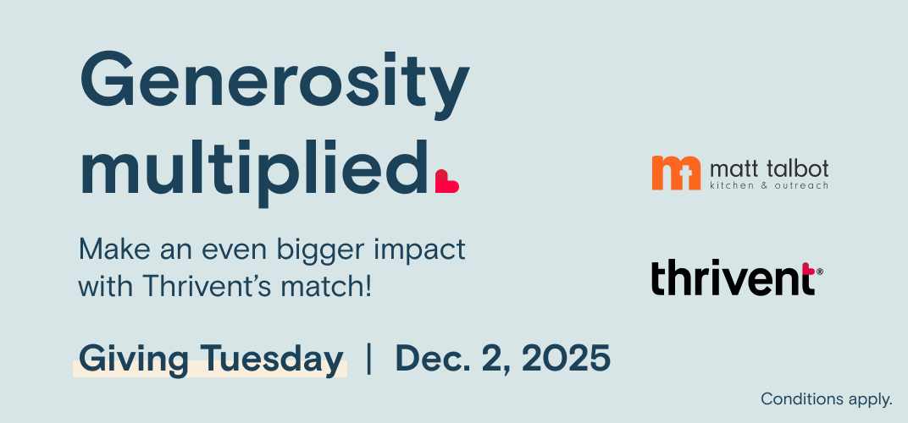

Dear [First Name @ a non-Lutheran church],

Get ready for a holly-jolly, sugar-and-smiles-filled afternoon that makes a real difference in Lincoln!

Cookies, Claus & Community is coming Tuesday, December 2 (Giving Tuesday!) to Sheridan Lutheran Church from 3:30 – 6:30 pm, and we’d love for your congregation to join the fun:

* [Santa emoji] Chat with Santa (don’t forget your wish lists!)
* [Heart emoji] Make care kits to support our neighbors at Matt Talbot Kitchen & Outreach
* [Cookie emoji] Decorate festive cookies to your heart’s content
* [Hot cocoa emoji] Sip hot cocoa by the mugful

And here’s the cherry on top - Thrivent is matching $1 for every $2 donated to Matt Talbot that day! That means your generosity goes twice as far to fight hunger, homelessness, and addiction in Lincoln.

Please share this information with your church family. Bulletin announcements, graphics, and flyers can be downloaded at mtko.org/events. If you have any questions, please contact Jenn at 402-817-0615 or jenn.boettcher@mtko.org.

Come for the cookies, stay for the Claus, and leave with a heart full of community, joy, and holiday cheer! Let’s make this Giving Tuesday sweet, festive, and unforgettable!

Warmly,

Alynn Sampson, MSW

Executive Director

*Donations made online to Matt Talbot through Thrivent’s giving platform and at in-person events on Giving Tuesday, Dec. 2, 2025, will be matched $1 for every $2 donated up to $20,000 per Thrivent Member Network. Thrivent will pay up to $300,000 in online processing fees per calendar year for personal donations made through Thrivent’s online giving platform.